TEMA: Present Perfect Tense

APERTURA

1.-We use the Present Perfect to talk about something that started in the past and continues in the present

2.- For something you have done several times in the past and continue to do

3.- We have the past participle of verbs in these actions

Example

They have played that video game several times in a week**.**

**Grammar Structure**

**☺ + has/have + verb in p.p + complement FOR/SINCE**

**☺ + hasn´t+ /haven´t + verb in p.p + complement yet**

**Has/ have + ☺ already+ verb in p.p + complement? yet**

**What/where/Why/When/ Has/ have + ☺ + verb in p.p + complement?**

**Grammar Structure**

**☺ + has/have *already*+ verb in p.p + complement**

**☺ + hasn´t+ /haven´t + verb in p.p + complement**

**Has/ have + ☺ +ever verb in p.p + complement?**

**SHORT ANSWERS Yes I have / no, I haven´t**

**Yes She has/ no, she hasn´t**

**Yes, they have/ no. they haven´t**

**No, not yet**

**No, I have never**

**DESARROLLO**

**Actividades Alumno**

1.-Identify grammar structure in book exercises pages 66 and make a review of verbs in past participle working on class



**A,.How long has she made calls?**

**B.-She has made calls for hours/ since 8 AM**

**C.-Has she made calls today? Different answers below**

**1.-She has already made calls/**

**2. -she hasn´t made calls yet/ -No, she has never.**

**D.-Has she ever made calls?**

**E.- Where has she made calls? She has made calls from that company.**

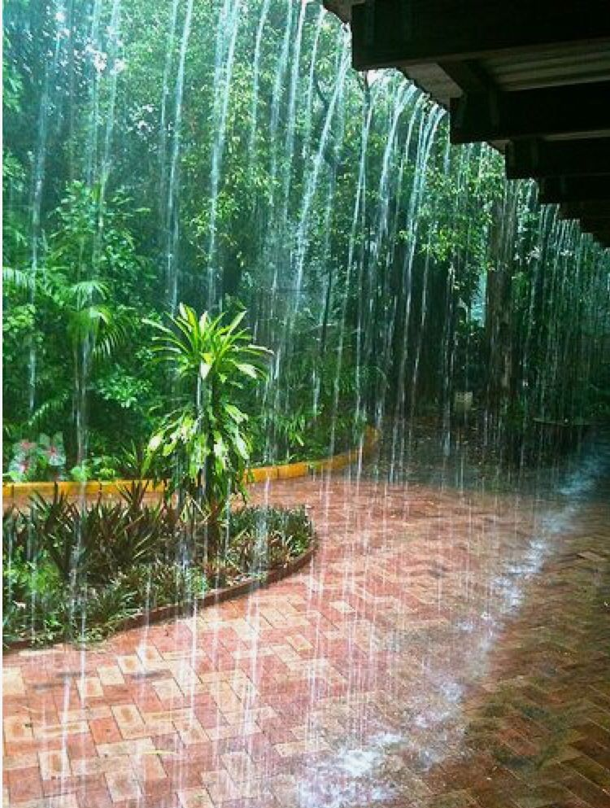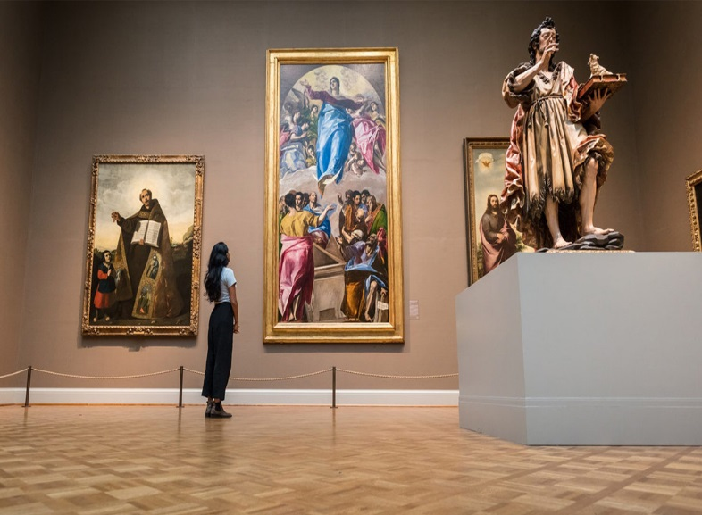

**CIERRE**

**PONDERACIÓN 10%**

<https://www.youtube.com/watch?v=ODt_xD5OhK8>

(present perfect video)

**CIERRE**

**Actividades Alumno**

Resolver ejercicios como consolidación del presente Perfecto Página 69 (class and send it the same day)

Study for exam workbook page Workbook page 17(trabajo individual)

*Complete the sentences below with ‘for or ‘since’.*

1. I’ve been working at this company ____________five years.

2. That restaurant has been open __________ this morning.

3. Kate has lived here __________ 2012.

4. It has been raining __________ a long time.

5. The TV has been on __________ five o’clock.

6. I have wanted to be a doctor __________ I was a kid.

7. Sam has studied at this college __________ only a week.

8. The telephone has been ringing __________ a few minutes.

9. Maria and Eduardo have been married __________ three months.

10. My uncle has been in the hospital __________ last Tuesday.

11. Dinosaurs have been extinct __________ 65 million years.

12. I’ve had this job __________ June.

13. I haven’t seen my friend __________ last week.

14. We’ve been waiting for our flight __________ an hour.

15. Stewart hasn’t eaten any junk food __________ several months.

|  |  |
| --- | --- |
| FOR (period of time)  Two years  One month  Three weeks  Two days  Five hours  15 minutes  Long time | SINCE (Exact time)  2001  February  Last week/month/year/Summer  Last Monday  Four hours ago  I was a child  3 o´clock  yesterday |

La lista de cotejo esta abajo de esta página

|  |  |  |  |
| --- | --- | --- | --- |
| 10.2 REPORTE: en expresión escrita reportar un ejemplo de un desastre natural  Ponderación :20% | | | |
| 1. La redacción cuenta con el total de palabras /oraciones asignadas |  |  |  |
| 2.-Hay coherencia en su reporte/oraciones |  |  |
| 1. La redacción/oraciones contiene oraciones con estructura gramatical |  |  |
| 4.El reporte/oraciones muestra originalidad del equipo |  |  |
| 5.Mantiene la idea principal en la redacción/oraciones |  |  |
| Total | 20% |  |  |